**Introduction / Business problem:**

Crime rates have gone high in various parts of the United States over the past few years. One of the noted states is California. To build a safer community we need to rely on various factors and one such factor is crime rate. Crime mapping is used by analysts in law enforcement agencies to map, visualize and analyze crime patterns. Geographic analysis can help reveal crime patterns and possible prevent future crimes from happening.

This would include:

* Examining where crimes occurred, and past offenders lived.
* Determining which neighborhoods attract more crime.
* How crimes differ in urban areas and rural areas?
* Finding crime hotspots and develop prevention strategies.
* Also helps public to decide on which neighborhood is safer to establish their property at.

Based on the above use cases, the following can be the potential stakeholders:

* Law enforcement agencies

These stakeholders will depend on this analysis in order to gather more information about the crimes around the state, arrive at a potential solution that would reduce the crime rate and possibly arrest the criminals responsible.

* Real-estate companies

These stakeholders will rely on this analysis in order to establish their properties and other constructions such that they don’t fall under neighborhoods having very high crime rates.

* General public (relying on safety)

These stakeholders are the people who are looking to buy a new house/property in a new neighborhood but would like to know how safe the neighborhood is.

**Data:**

The data used for the above problem can be found at the DATASF website:

(<https://data.sfgov.org/Public-Safety/Police-Department-Incident-Reports-Historical-2003/tmnf-yvry>).

This dataset includes police incident reports filed by officers and by individuals through self-service online reporting for non-emergency cases. Reports included are those for incidents that occurred starting 2003 to 2018 and have been approved by a supervising officer. The dataset contains fields like incident date, time, location, report type, category, longitude, latitude etc. This dataset contains the location information of each crime hotspots which can be used with the foursquare location data for the map visualization and analysis.

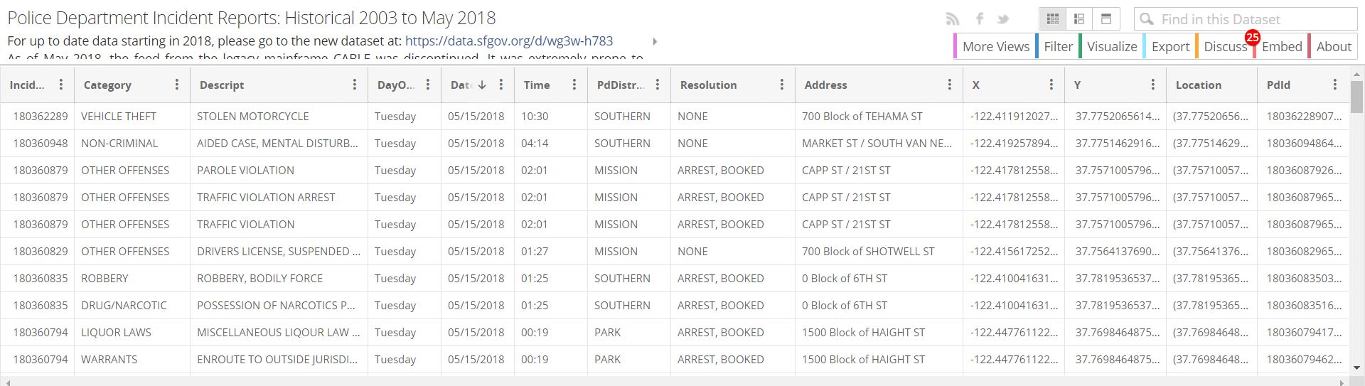

All additional information about the dataset can be found at:

<https://bit.ly/2x7Ta2P>